**BUILDING FOUR-WHEELED ROBOT IN ROS USING URDF**

In this tutorial we are going to build a four- wheeled robot in ROS using URDF (Unified Robot Description Format). And also integrating camera and hokuyo laser module sensor to detect obstacle’s on this robot.

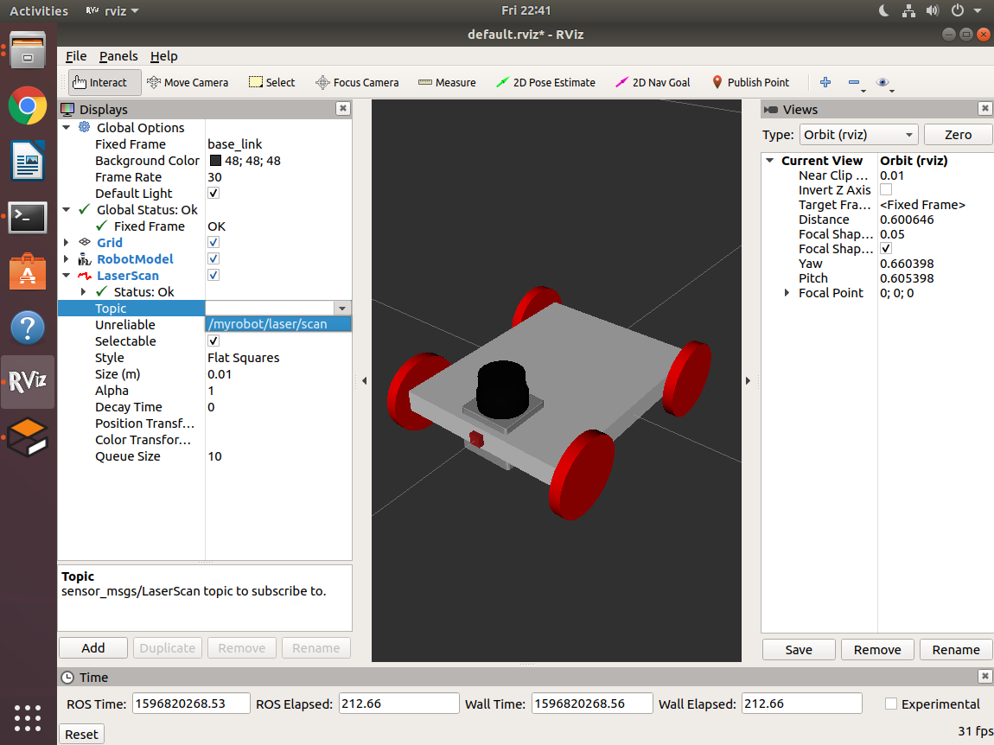

**PREREQUISITES:**

1. Ubuntu installed PC with at least 8GB of RAM and 1GB of Graphics card
2. ROS installed melodic version
3. Basics using terminal in ubuntu
4. Creating packages, topics in ros
5. Basic Xml concepts
6. Creating robot model in ros using xml
7. RVIZ visualize
8. Gazebo simulator

**TASKS INVOLVED:**

1. Building robot using URDF
   * 1. Define Chassis dimensions
     2. Defining wheels dimensions
     3. Linking of wheels with chassis using joints concept
2. Visualization of robot in RVIZ
3. Moving robot in Gazebo Simulation (using teleop_twist_keyboard package)
4. Linking camera with the chassis
5. Placing objects and obstacles in gazebo simulator
6. Visualization of camera output in RVIZ
7. Linking hokuyo sensor with chassis
8. Placing objects and obstacles in Gazebo simulator
9. Visualization obstacles as points in RVIZ
10. Final robot

Before starting the project we need make the structure of robot.

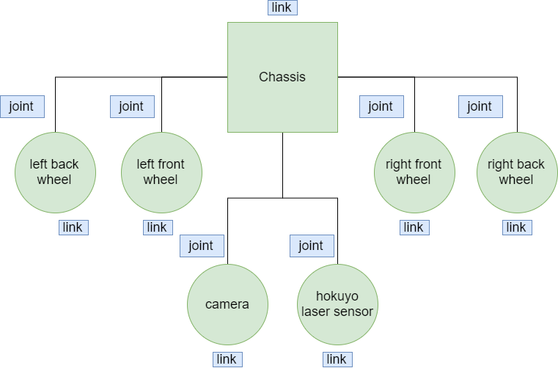

1. **Building Robot Model**

* Create workspace in ubuntu. Open terminal in ubuntu and create a workspace **robot_ws** with src folder in it in home using mkdir command.

mkdir robot_ws

cd robot_ws

mkdir src

* Moving to src folder and create a package named **m4w_robot** with urdf directory in it.

catkin_create_pkg m4w_robot urdf rospy roscpp std_msgs

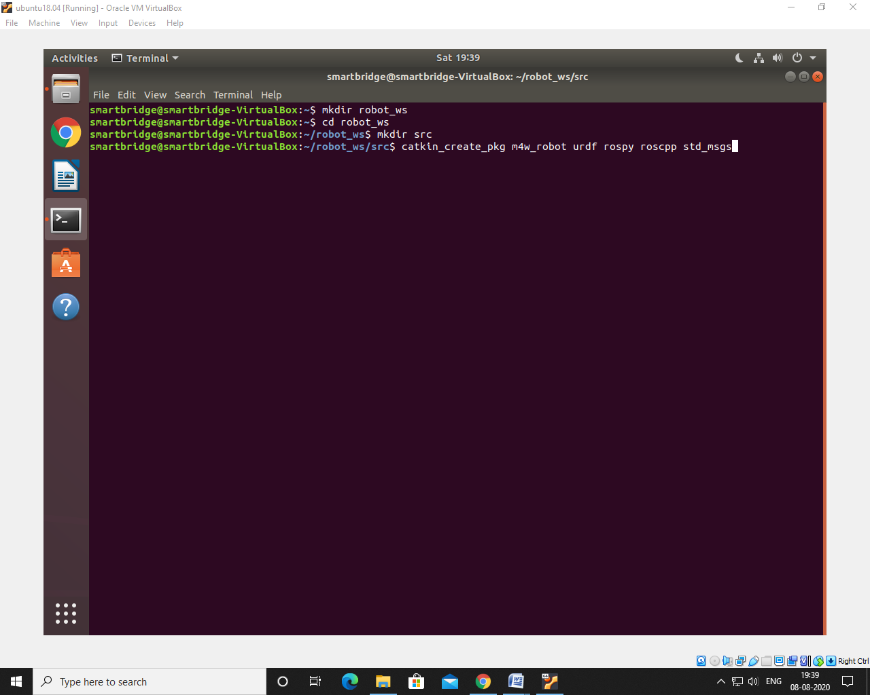

* After that moving back workspace directory and build the package

catkin_make

* After building the packages move into that package and here starts the main process.

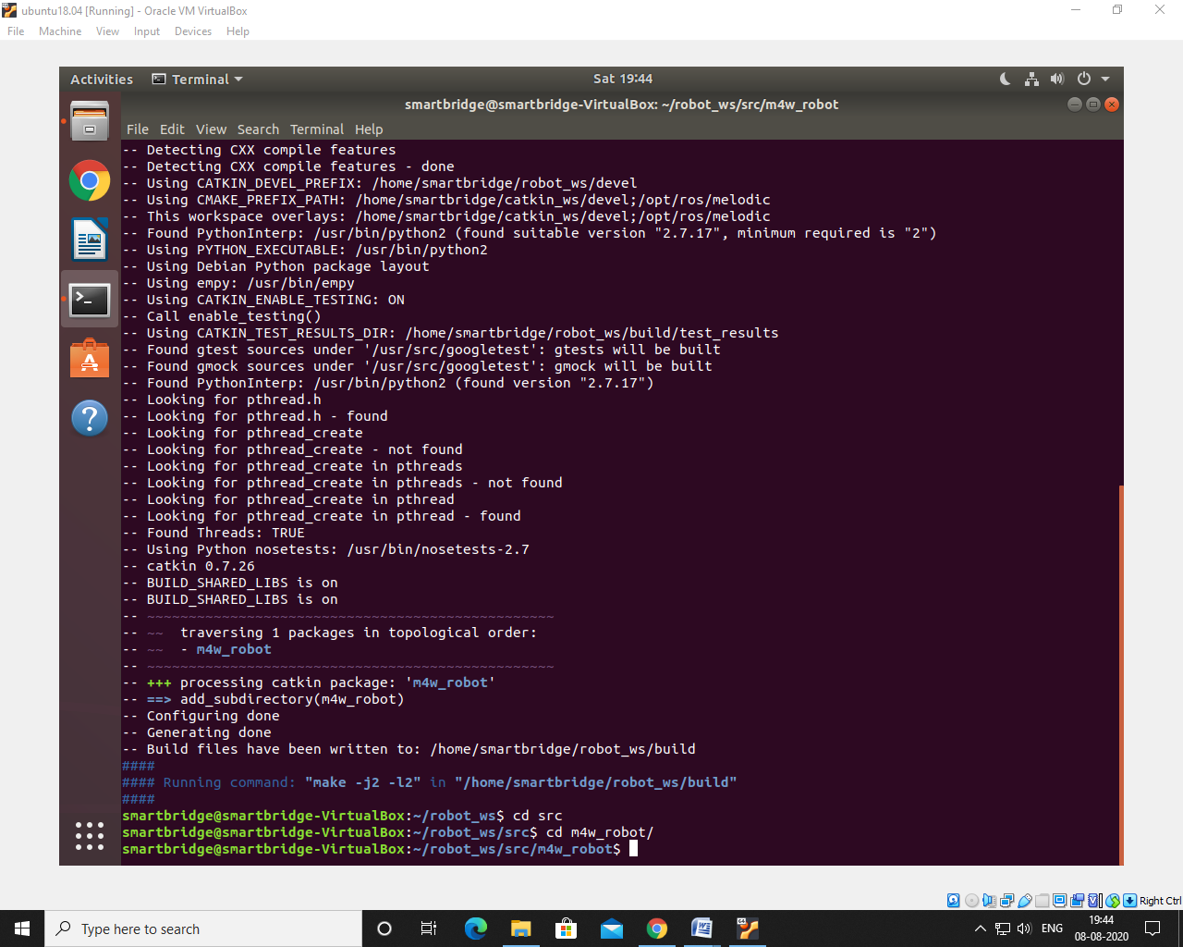

1. **Defining dimensions of the chassis.**

* In **m4w_robot** package create **urdf** folder and in this folder create a xacro file with name **m4w_robot.xacro.**

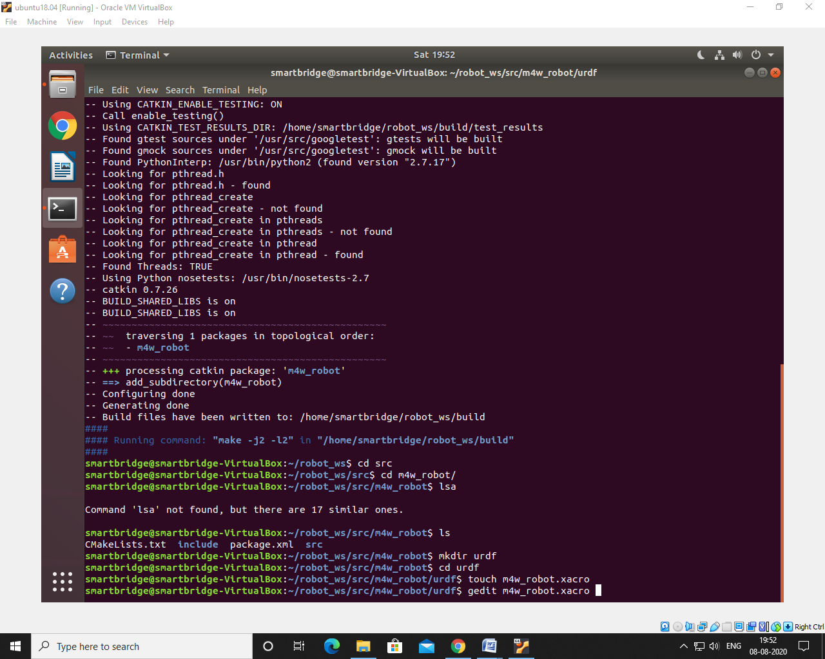

* In this xacro define the dimensions of chassis using xml tags.
* For creating chassis you need to mention chassis length, width, height and mass of that particular chassis.
* Here in this project I have specified the dimensions of robot in meters and mass in kilograms and also do not forget to give inertia to chassis. Here I have specified formulas for inertia of chassis.

1. **Defining dimensions of wheels**

* For wheel dimensions use cylinder geometry type to define the wheel properties.
* For dimensions specify wheel radius and height and also mass of wheel.

1. **Linking of wheels with chassis using joints concept**

* After specifying dimensions of chassis and wheel our next task is to link chassis with wheels using joint tags.

Final code for designing this robot: <https://tinyurl.com/robot-design>

1. **Visualization of robot in RVIZ**

* Robot design is done.
* Next step is to visualize the robot in RVIZ
* In **m4w_robot** packagefolder create **launch** folder and in this folder create **rviz.launch** file to open xacro file in RVIZ.
* Code to visualize robot in RVIZ

|  |  |
| --- | --- |
|  | <?xml version="1.0"?> |
|  |  |
|  | <param name="robot_description" command="$(find xacro)/xacro.py '$(find m4w_robot)/urdf/m4w_robot.xacro'"/> |
|  |  |
|  | <!-- send fake joint values --> |
|  | <node name="joint_state_publisher" pkg="joint_state_publisher" type="joint_state_publisher"> |
|  | <param name="use_gui" value="False"/> |
|  | </node> |
|  |  |
|  | <!-- Combine joint values --> |
|  | <node name="robot_state_publisher" pkg="robot_state_publisher" type="robot_state_publisher"/> |
|  |  |
|  | <!-- Show in Rviz --> |
|  | <node name="rviz" pkg="rviz" type="rviz" /> |
|  |  |
|  | </launch> |

* After saving the file open rviz file from terminal using

roslaunch m4w_robot rviz.launch

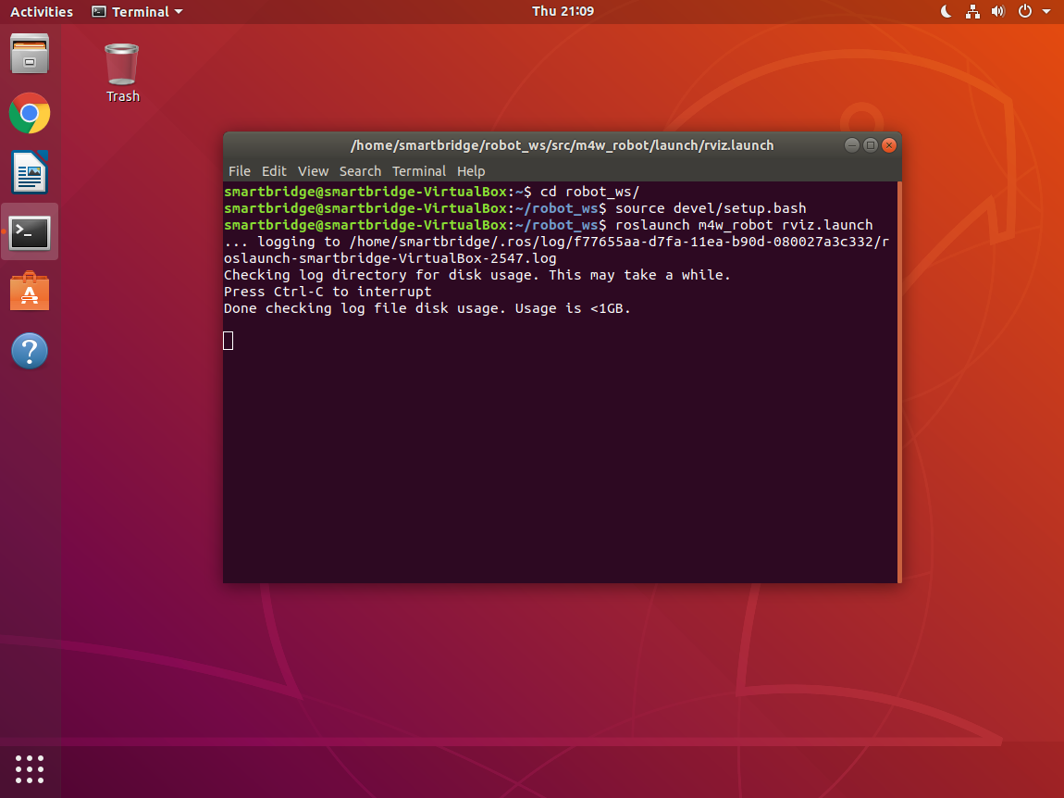

* Rviz will be loaded, in rviz in fixed frame drop down choose base_link which is chassis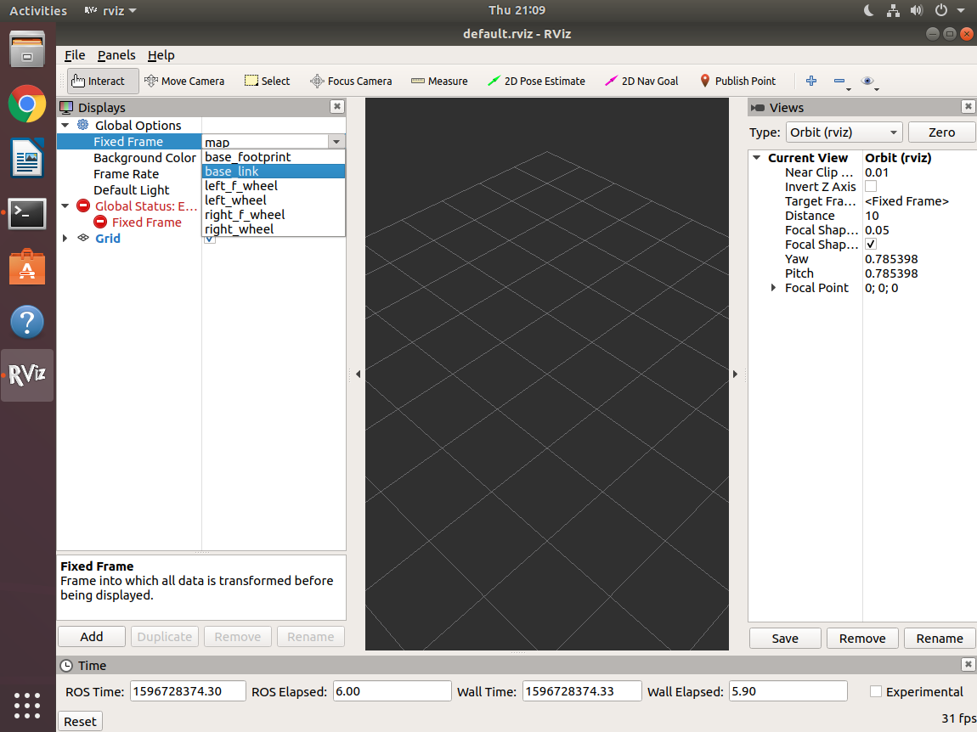
* In rviz click on add to add robot model to view the robot.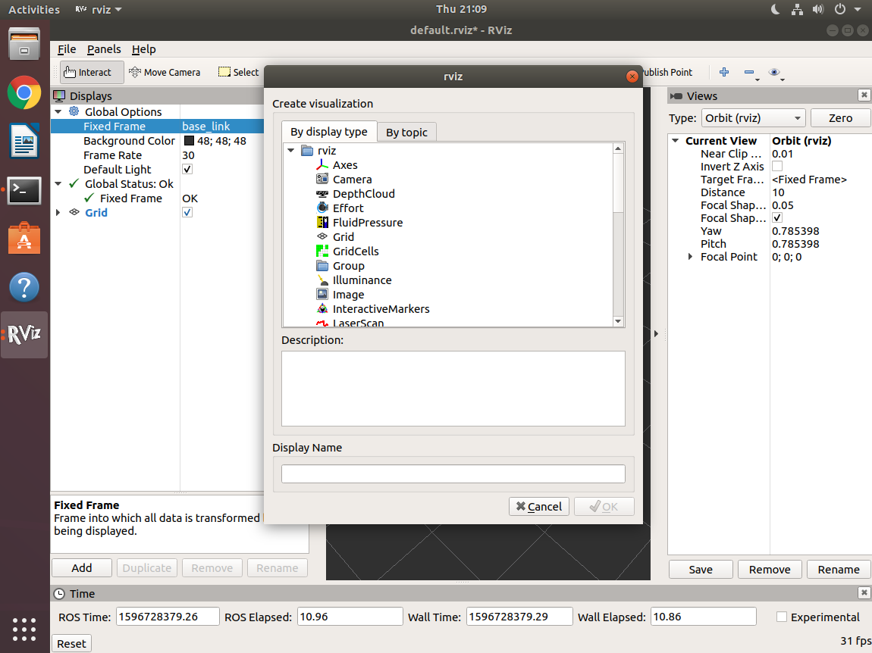
* Select robot model in display type and click on OK to view robot model in RVIZ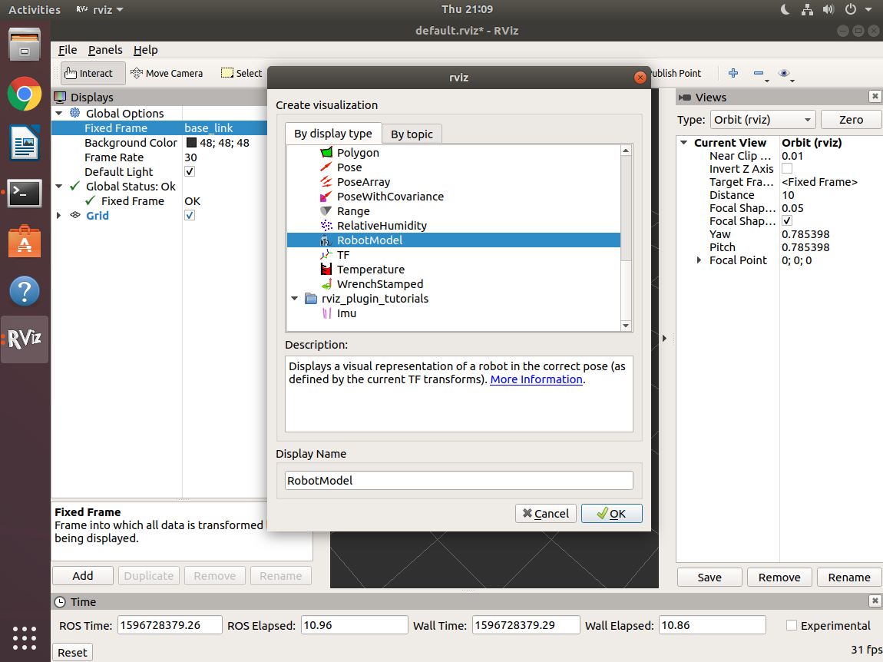
* In the display zoom we can see the robot model.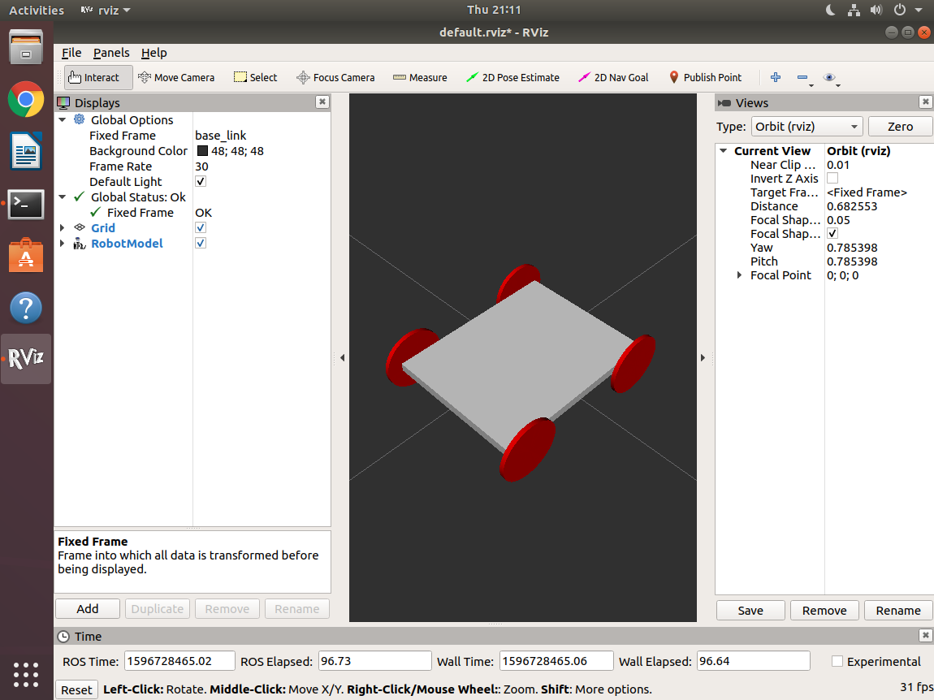

1. **Moving robot in Gazebo Simulation**

* We have visualized robot in RVIZ and now let us simulate robot in 3D world i.e., gazebo simulator.
* To view robot in gazebo, we need to create a gazebo file in urdf folder with name **m4w_robot.gazebo** and also **materials.xacro** file to specify the colors of the robot to view that in gazebo simulator.
* Code to view robot in Gazebo simulator and to add gazebo plugin to operate robot. Here, we have used skid steer controller for controlling this four wheel robot.

<https://tinyurl.com/ros-gazebo>

* To view robot in gazebo simulator in **launch** folder create **spawn.launch** file to view robot in 3D world.
* Code to view robot in 3D world.

|  |
| --- |
| <?xml version="1.0" encoding="UTF-8"?>  <launch> |
| <param name="robot_description" command="$(find xacro)/xacro.py '$(find m4w_robot)/urdf/m4w_robot.xacro'" /> |
|  |
| <arg name="x" default="0"/> |
| <arg name="y" default="0"/> |
| <arg name="z" default="0"/> |
|  |
| <node name="mybot_spawn" pkg="gazebo_ros" type="spawn_model" output="screen" |
| args="-urdf -param robot_description -model m2wr -x $(arg x) -y $(arg y) -z $(arg z)" /> |
| </launch> |

* By now. The folders and files, hierarchy would look like this,

└────── robot_ws

├─── build

├─── devel

└─── src

├── CMakeLists.txt

└── m4w_robot

├── CMakeLists.txt

├── launch

│ ├── rviz.launch

│ └── spawn.launch

├── package.xml

└── urdf

└── m4w_robot.xacro

└── m4w_robot.gazebo

* Open robot in rviz and open new terminal and in this terminal type,

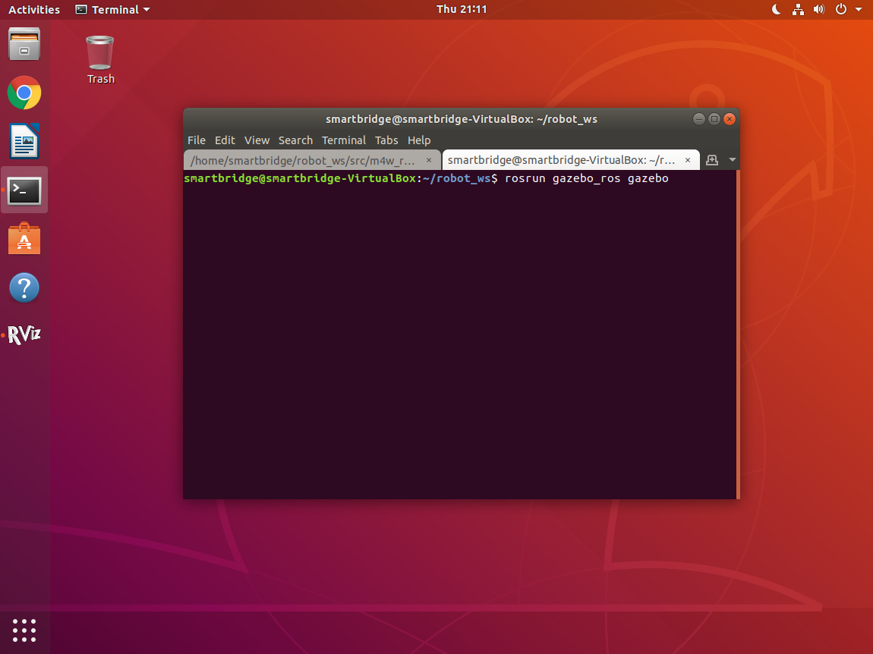

rosrun gazebo_ros gazebo

* Gazebo simulator will be launched, to view robot in this world **spawn.launch** file should be run. To run spawn.launch, open a new terminal and type

roslaunch m4w_robot spawn.launch

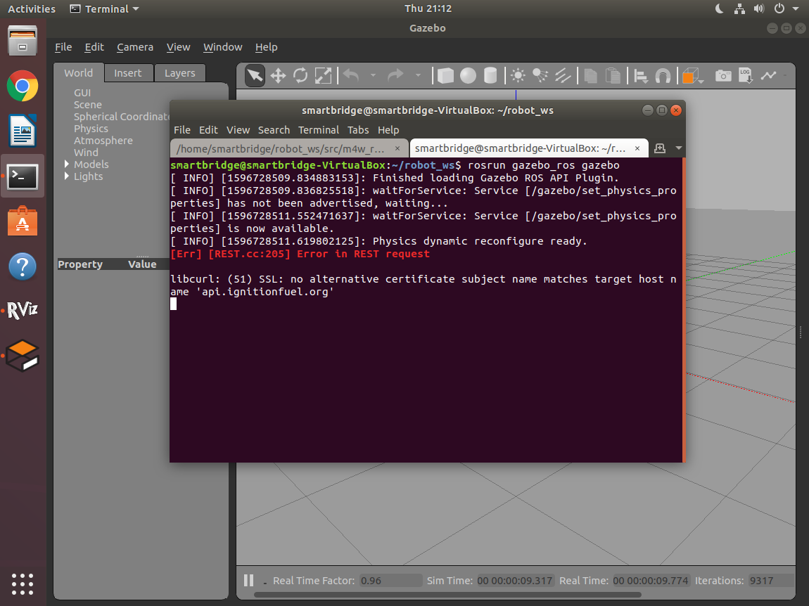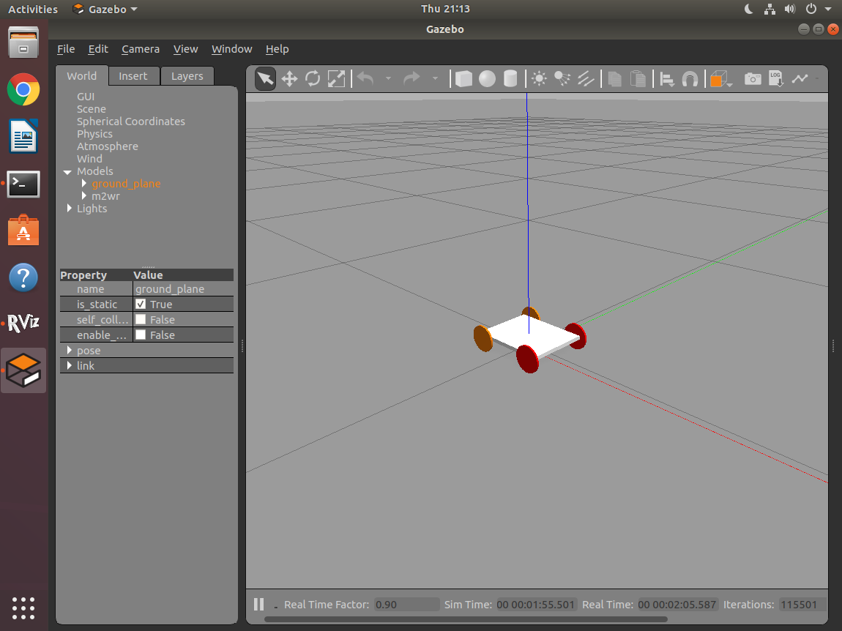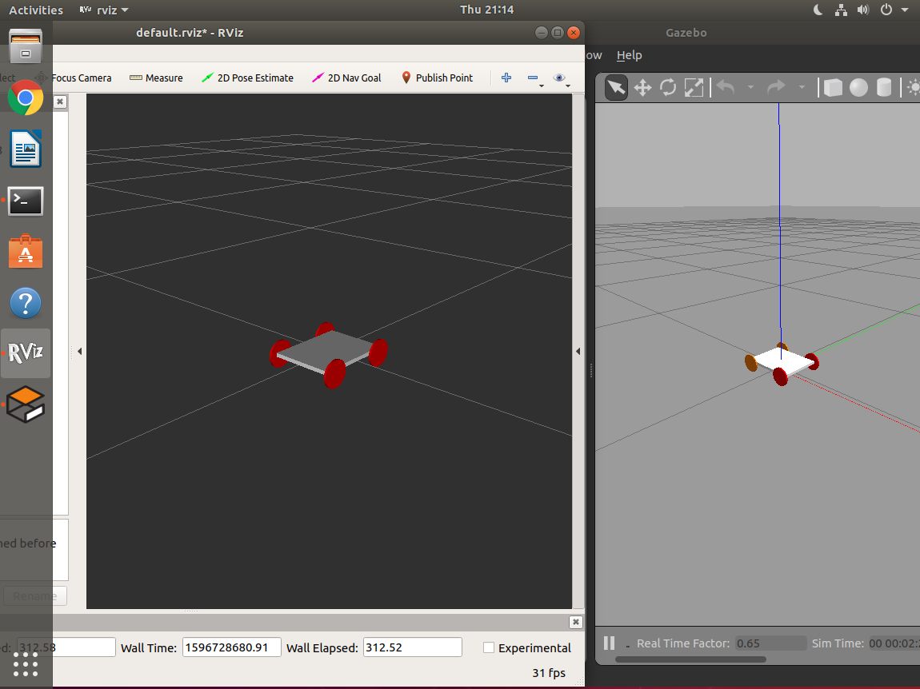

* Robot will be loaded into the world and now let us operate using keyboard keys by using teleop package. Open terminal and rosrun teleop_twist_keyboard to operate the robot.

Rosrun teleop_twist_keyboard teleop_twist_keyboard.py

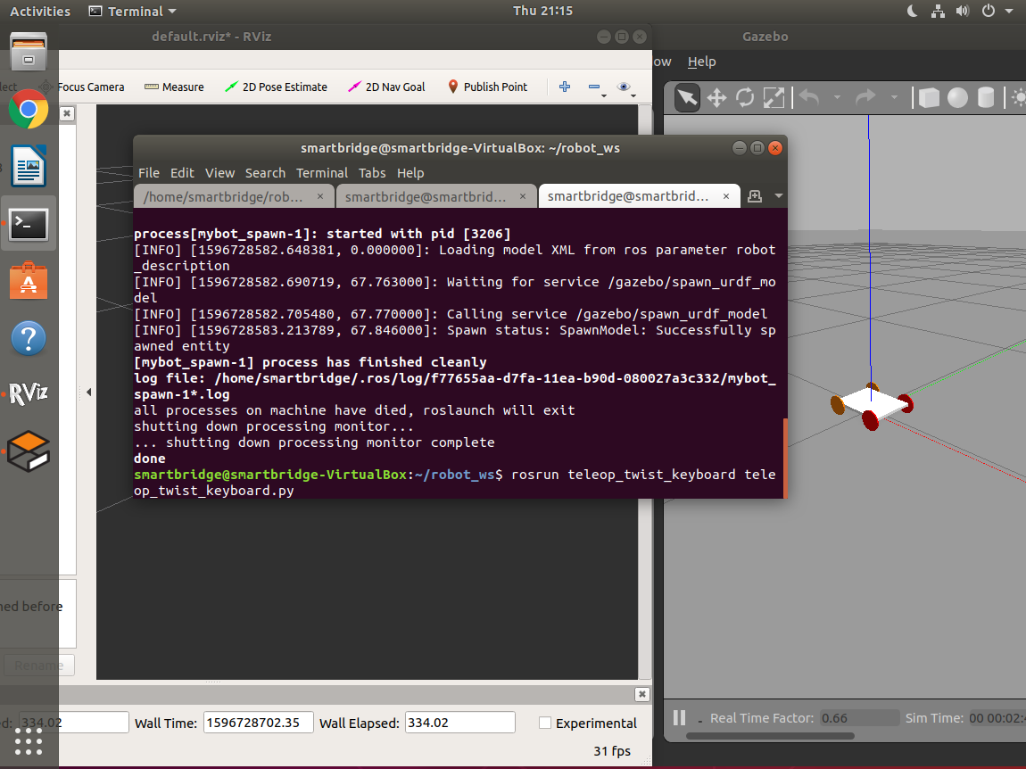

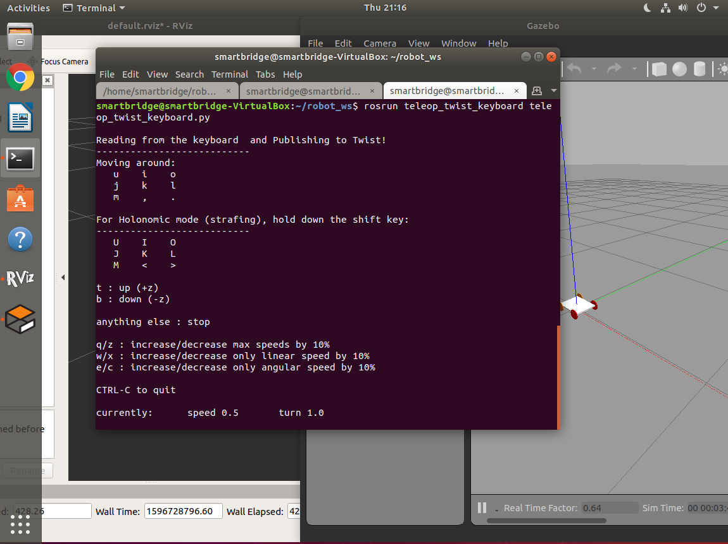

* Now you can operate the robot using the keys displayed in terminal window.

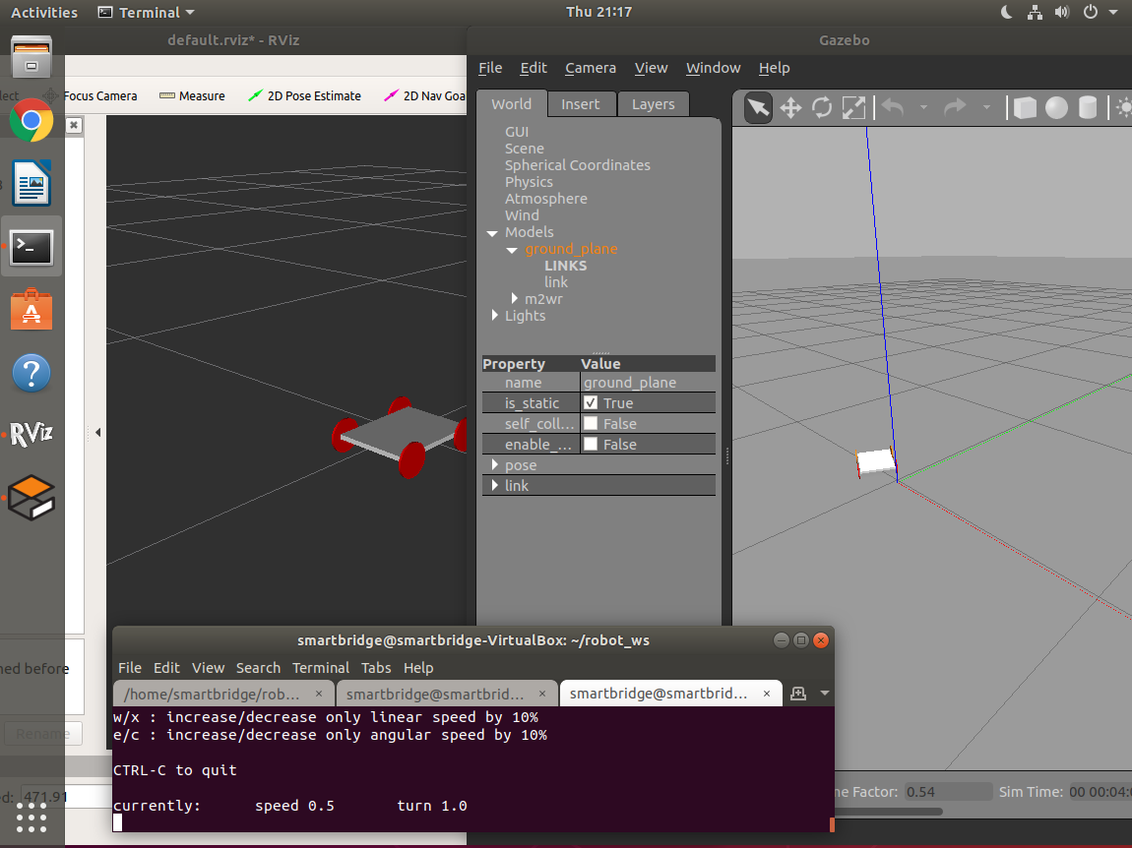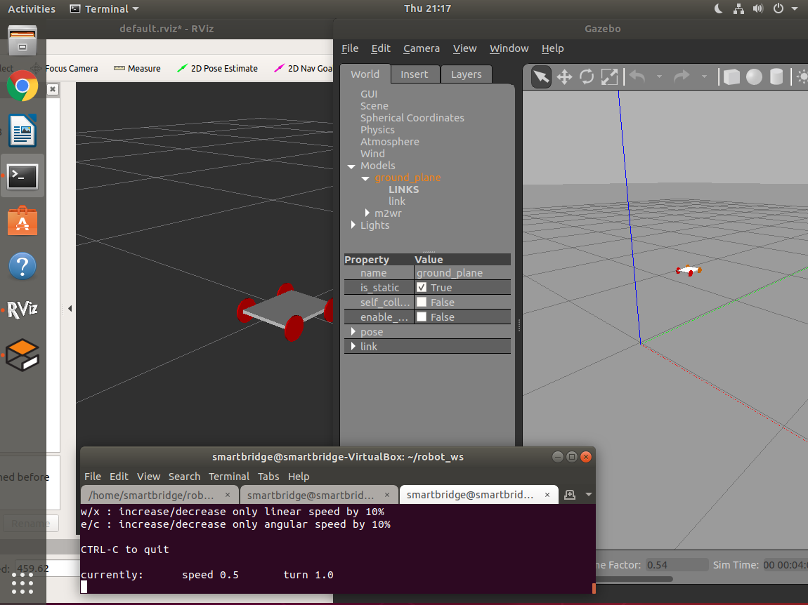

1. **Linking camera with the chassis**

* Now let us integrate camera to robot and view the object of the world in RVIZ visualization.
* To integrate camera with robot, we need to mention camera tags in **m4w_robot.xacro** file as well as mention plugins tags in **m4w_robot.gazebo.**
* Tags to mention in xacro file.

|  |  |
| --- | --- |
|  | <xacro:property name="camera_link" value="0.01" /> |
|  |  |
|  | <!-- Camera --> |
|  | <link name="camera_link"> |
|  | <collision> |
|  | <origin xyz="0 0 0" rpy="0 0 0"/> |
|  | <geometry> |
|  | <box size="${camera_link} ${camera_link} ${camera_link}"/> |
|  | </geometry> |
|  | </collision> |
|  |  |
|  | <visual> |
|  | <origin xyz="0 0 0" rpy="0 0 0"/> |
|  | <geometry> |
|  | <box size="${camera_link} ${camera_link} ${camera_link}"/> |
|  | </geometry> |
|  | <material name="red"/> |
|  | </visual> |
|  |  |
|  | <inertial> |
|  | <mass value="0.1" /> |
|  | <origin xyz="0 0 0" rpy="0 0 0"/> |
|  | <inertia ixx="1e-6" ixy="0" ixz="0" iyy="1e-6" iyz="0" izz="1e-6" /> |
|  | </inertial> |
|  | </link> |
|  |  |
|  |  |
|  | <joint name="camera_joint" type="fixed"> |
|  | <axis xyz="0 1 0" /> |
|  | <origin xyz="${base_len/2} 0 0" rpy="0 0 0"/> |
|  | <parent link="base_link"/> |
|  | <child link="camera_link"/> |
|  | </joint> |

* Tags to mention in gazebo file.

|  |  |
| --- | --- |
|  | <gazebo reference="camera_link"> |
|  | <sensor type="camera" name="camera1"> |
|  | <update_rate>30.0</update_rate> |
|  | <camera name="head"> |
|  | <horizontal_fov>1.3962634</horizontal_fov> |
|  | <image> |
|  | <width>800</width> |
|  | <height>800</height> |
|  | <format>R8G8B8</format> |
|  | </image> |
|  | <clip> |
|  | <near>0.02</near> |
|  | <far>300</far> |
|  | </clip> |
|  | </camera> |
|  | <plugin name="camera_controller" filename="libgazebo_ros_camera.so"> |
|  | <alwaysOn>true</alwaysOn> |
|  | <updateRate>0.0</updateRate> |
|  | <cameraName>m4w_bot/camera1</cameraName> |
|  | <imageTopicName>image_raw</imageTopicName> |
|  | <cameraInfoTopicName>camera_info</cameraInfoTopicName> |
|  | <frameName>camera_link</frameName> |
|  | <hackBaseline>0.07</hackBaseline> |
|  | <distortionK1>0.0</distortionK1> |
|  | <distortionK2>0.0</distortionK2> |
|  | <distortionK3>0.0</distortionK3> |
|  | <distortionT1>0.0</distortionT1> |
|  | <distortionT2>0.0</distortionT2> |
|  | </plugin> |
|  | </sensor> |
|  | </gazebo> |

* We have mention tags in xacro and gazebo file, next step is to place some obstacles in the world.

1. **Placing objects and obstacles in gazebo simulator**

* To view robot in gazebo world, we need to create a new package **m4w_robot_gazebo** in src folder of workspace and this package we need to create to two folders **launch**  and **worlds** folder.
* In **worlds** folder create **mybot.world** file.
* Code to create world in gazebo

<https://tinyurl.com/world-file>

* Open robot model in RVIZ and add camera display type in RVIZ.
* To view robot in gazebo world, first we need to open robot in RVIZ. To open RVIZ type,

roslaunch m4w_robot rviz.launch

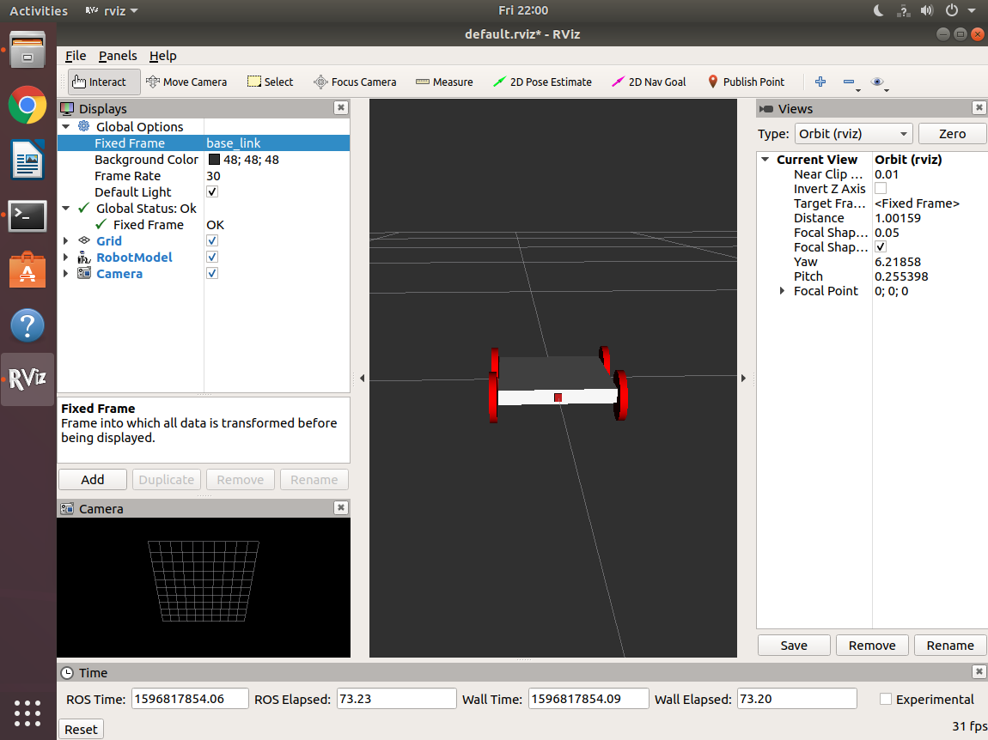

* Now open terminal and by using m4w_robot_gazebo package we can directly open gazebo simulator with robot in it.

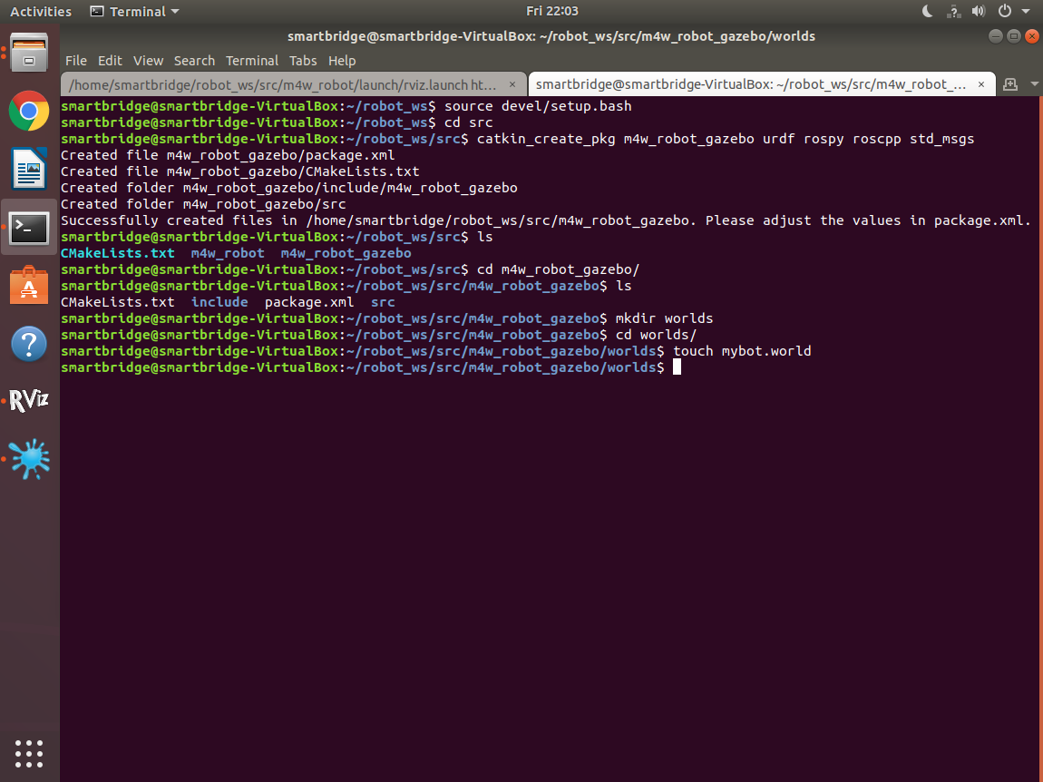

* After creating the package, we need to build the package. To build package go back to **robot_ws** in terminal and type.

catkin_make

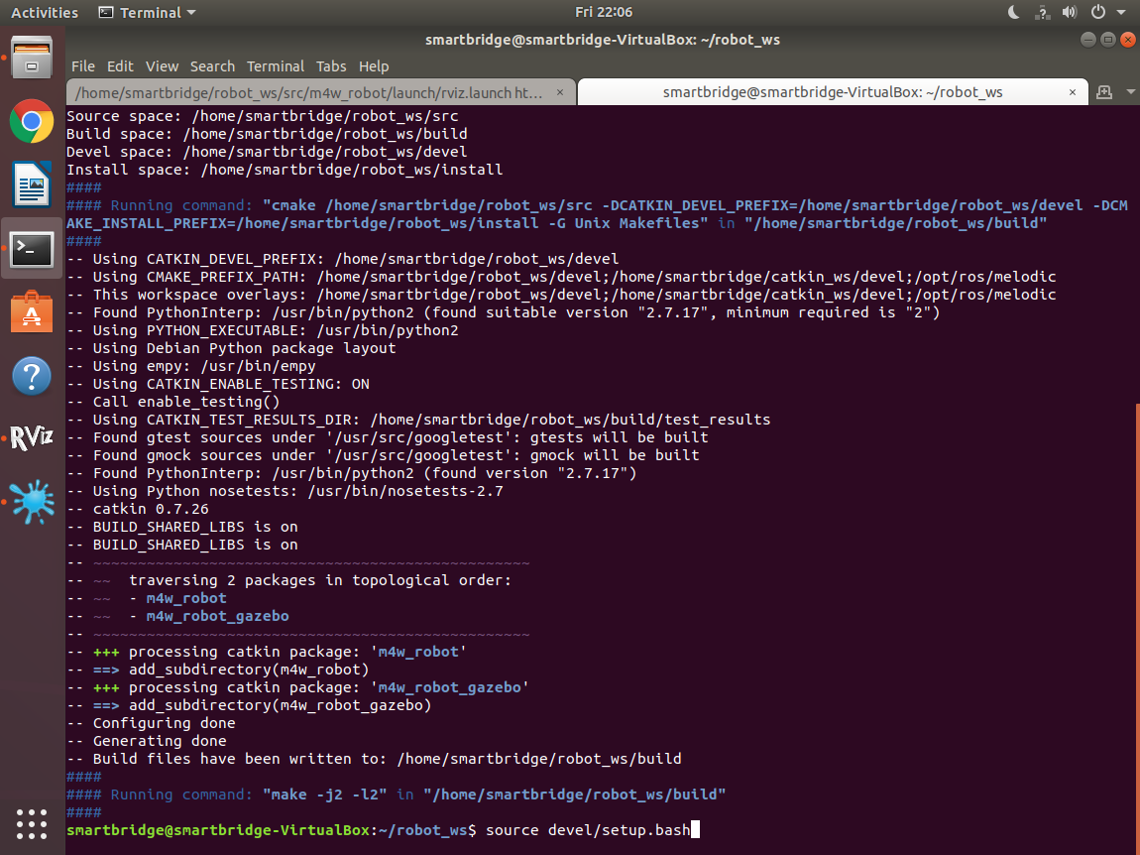

* In **launch** folder create **mybot_world.launch** and specify the xacro file in this launch file.
* Code to create launch file

<https://tinyurl.com/launch-file>

* By now. The folders and files, hierarchy would look like this,

└────── robot_ws

├─── build

├─── devel

└─── src

├── CMakeLists.txt

└── m4w_robot

├── CMakeLists.txt

├── launch

│ ├── rviz.launch

│ └── spawn.launch

├── package.xml

└── urdf

└── m4w_robot.xacro

└── m4w_robot.gazebo

└── materials.xacro

└── m4w_robot_gazebo

├── CMakeLists.txt

├── launch

│ └── mybot_world.launch

├── package.xml

└── worlds

└── mybot.world

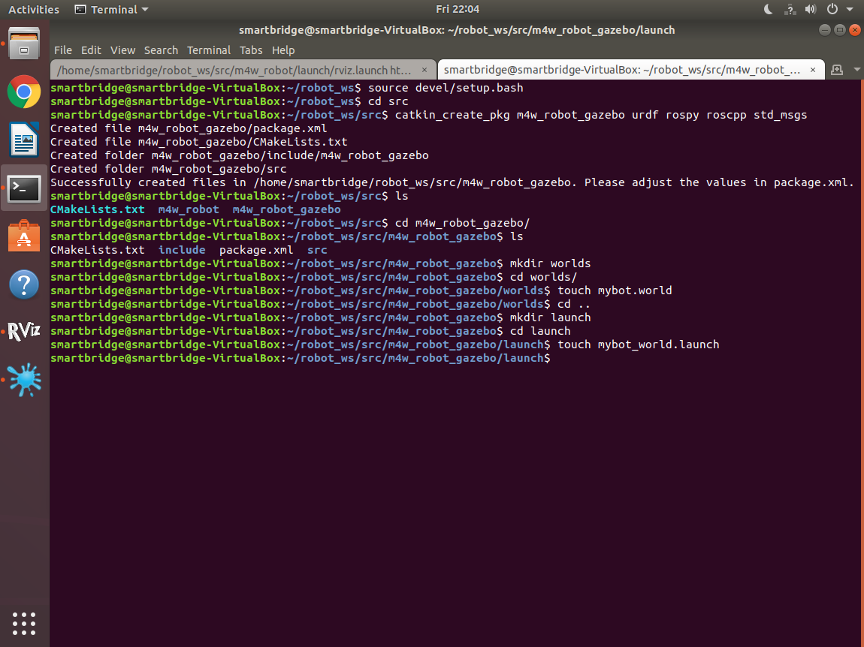

* To open gazebo simulator with robot in it, open terminal and type

roslaunch m4w_robot_gazebo mybot_world.launch

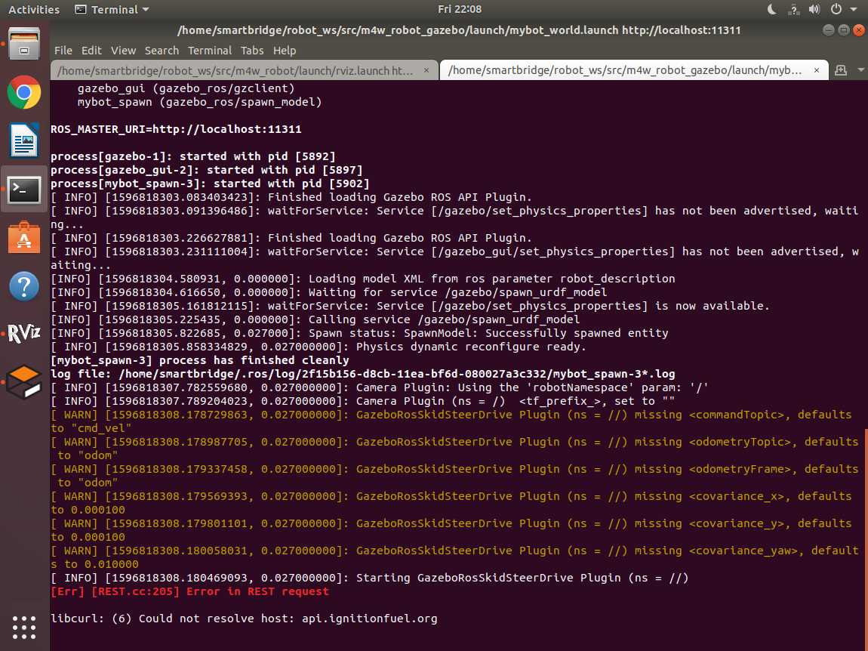

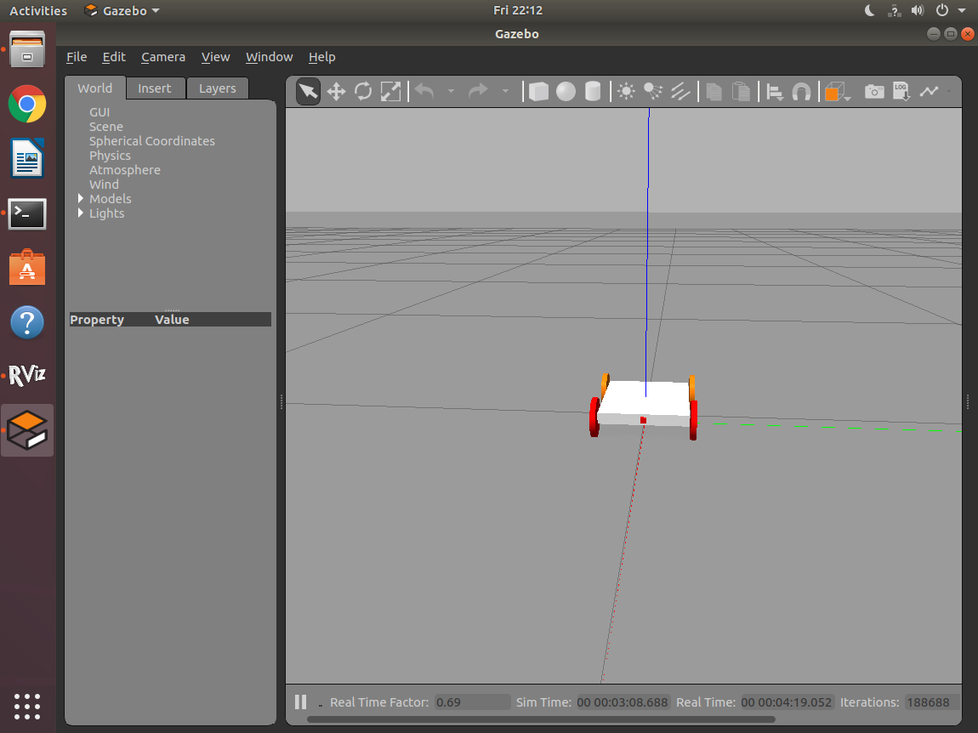

* After loading robot in gazebo simulator, we need to place some obstacles and objects in gazebo world to view them in RVIZ.

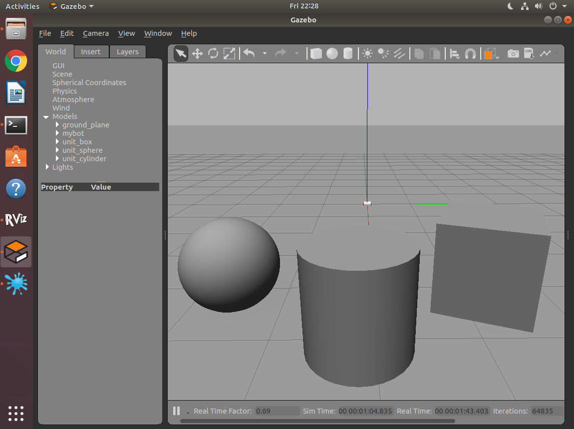

1. **Visualization of camera output in RVIZ**

* To open robot in RVIZ, open terminal and type

roslaunch m4w_robot rviz.launch

* To view camera output of robot in RVIZ.
* Open RVIZ and and add camera from display type.

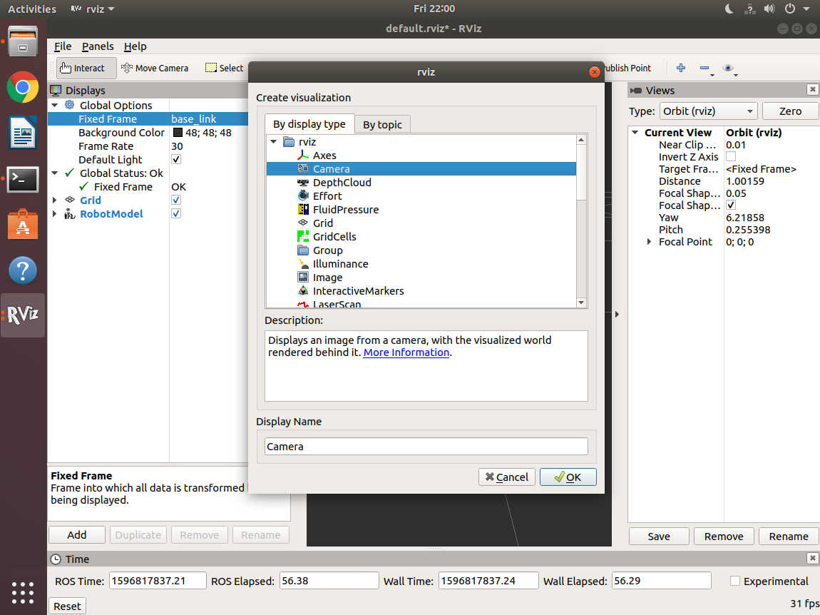

* In camera display type properties, in image topic select the image topic from drop down list; a small camera pop-up will be opened to see camera output in RVIZ.

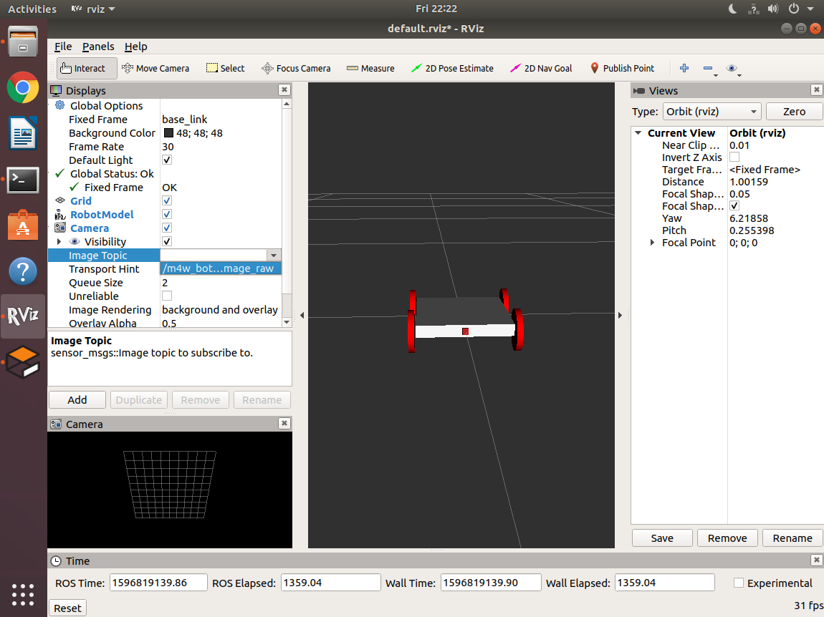

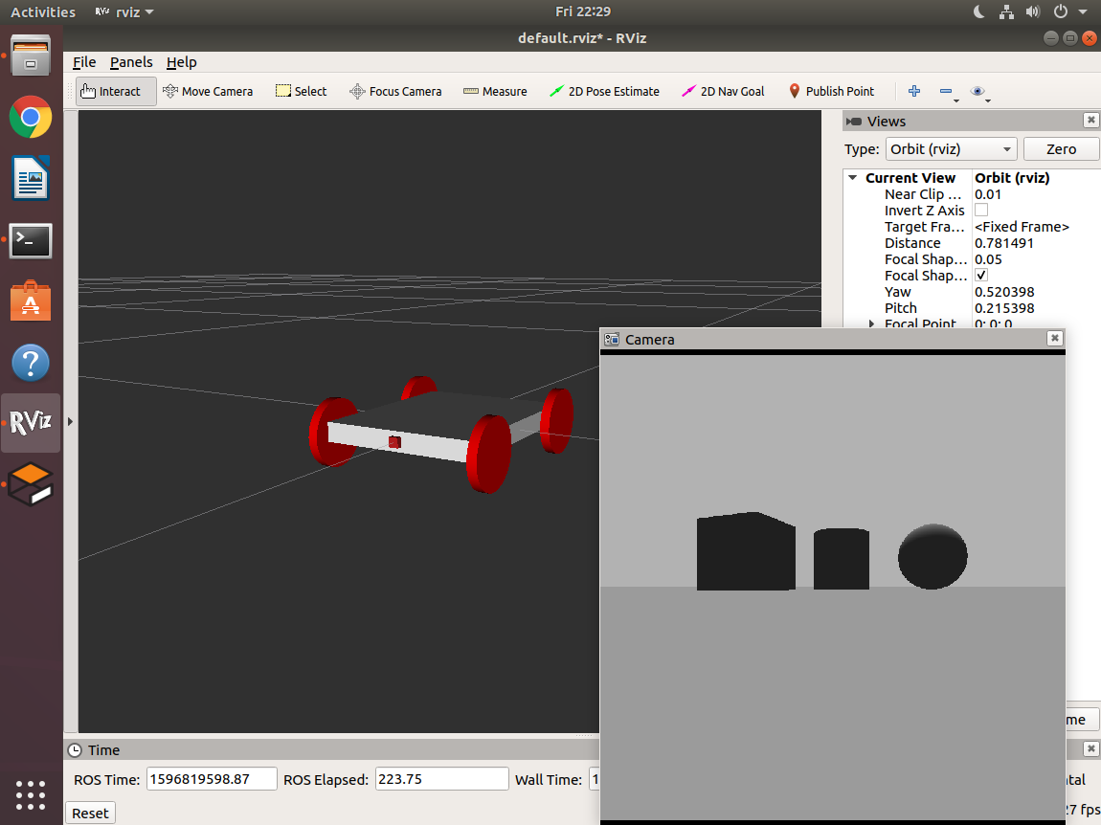

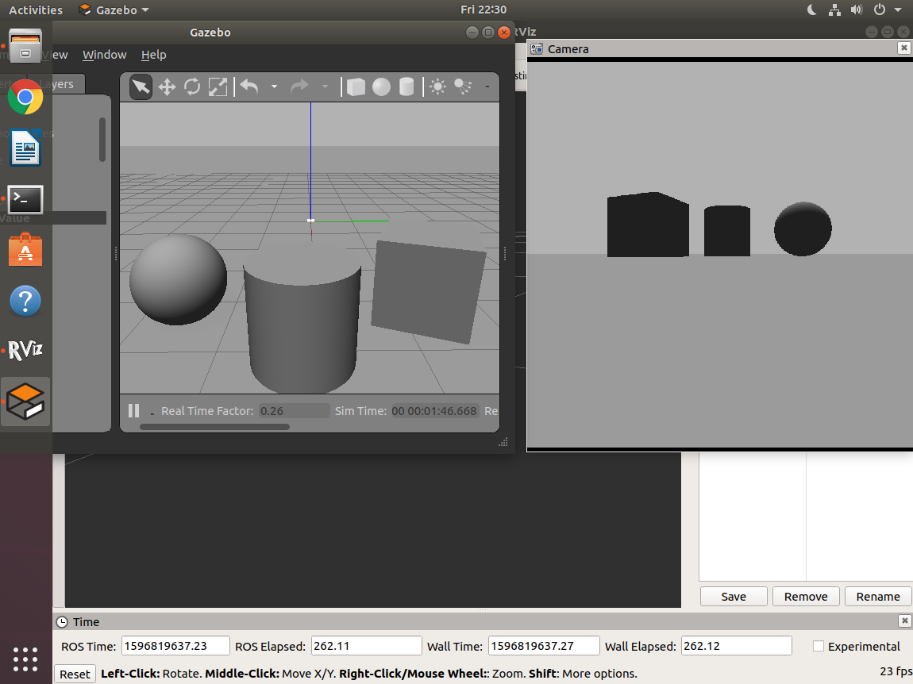

* Use teleop_twist_keyboard package to move robot in the world and see the output in camera display in RVIZ.

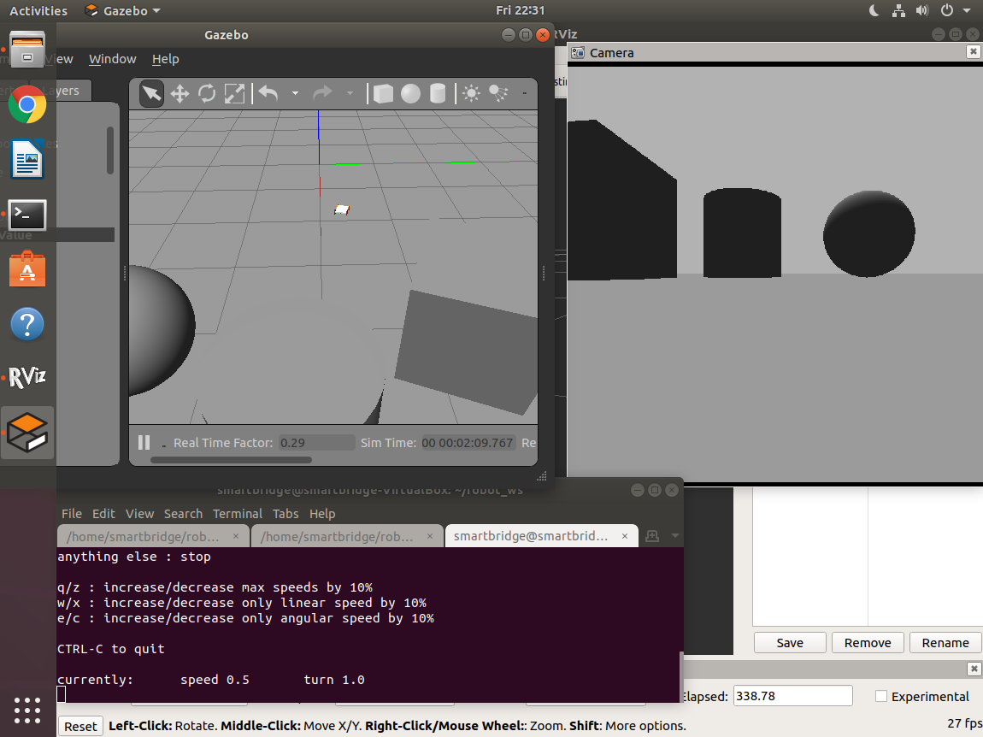

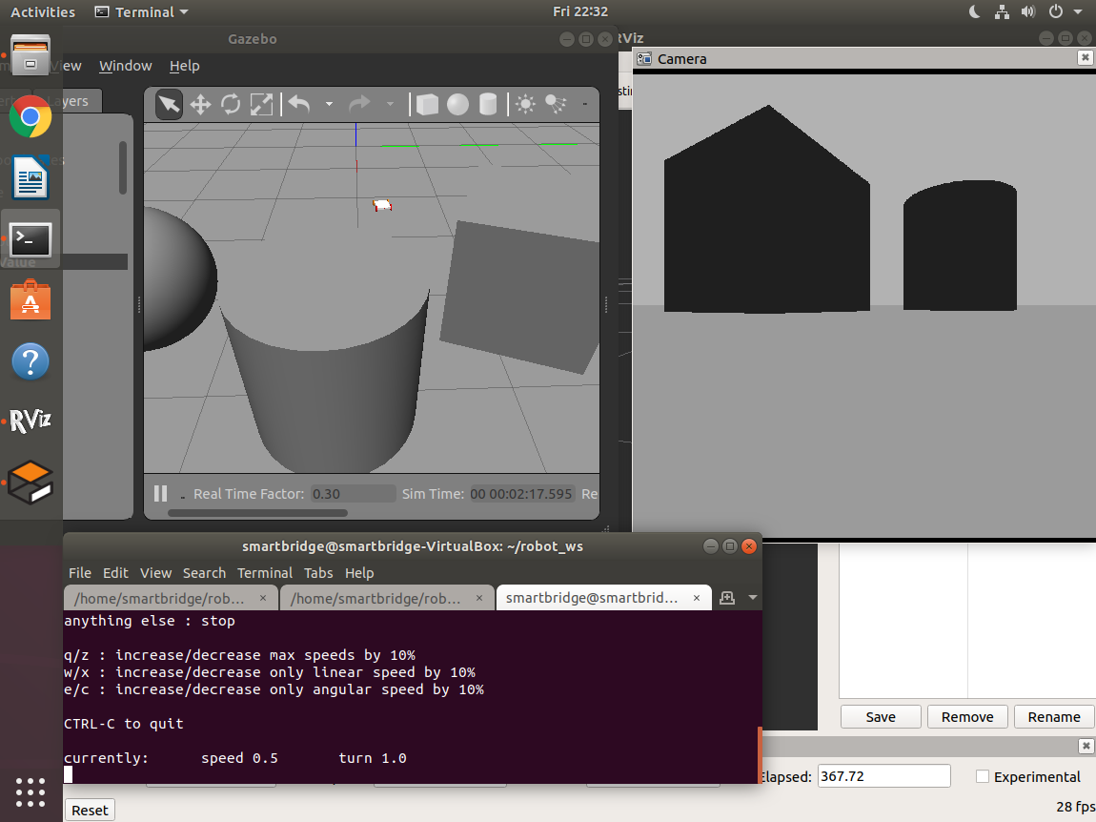

1. **Linking hokuyo sensor with chassis**

* Now let us integrate Hokuyo laser sensor with robot to detect obstacles in the world and show obstacles as points in RVIZ.
* Hokuyo laser sensor is used to detect obstacles in the range of 0 degrees to 180 degrees.
* To integrate laser sensor with robot we need to specify laser sensor tags in **m4w_robot.xacro** file and as well as hokuyo laser plugin in **m4w_robot.gazebo** file.
* Code to view laser module in RVIZ

|  |
| --- |
| <link name="hokuyo"> |
| <collision> |
| <origin xyz="0 0 0" rpy="0 0 0"/> |
| <geometry> |
| <box size="0.03 0.03 0.03"/> |
| </geometry> |
| </collision> |
|  |
| <visual> |
| <origin xyz="0 0 0" rpy="0 0 0"/> |
| <geometry> |
| <mesh filename="package://m4w_robot/meshes/hokuyo.dae"/> |
| </geometry> |
| <material name="green"/> |
| </visual> |
|  |
| <inertial> |
| <mass value="1e-5" /> |
| <origin xyz="0 0 0" rpy="0 0 0"/> |
| <inertia ixx="1e-6" ixy="0" ixz="0" iyy="1e-6" iyz="0" izz="1e-6" /> |
| </inertial> |
| </link> |
|  |
| <joint name="hokuyo_joint" type="fixed"> |
| <axis xyz="0 1 0" /> |
| <origin xyz="${base_len/2-0.03} 0 0.01" rpy="0 0 0"/> |
| <parent link="base_link"/> |
| <child link="hokuyo"/> |
| </joint> |

* Here in above code we have mentioned **.dae** file in geometry which is 3D design of the laser module. To specify this 3D design of sensor, create this sensor package file in **meshes** folder of **m4w_robot** package.
* Code to specify **hokuyo.dae** file

<https://tinyurl.com/hokuyo-file>

* Code to specify laser plugin in gazebo file

|  |
| --- |
| <gazebo reference="hokuyo"> |
| <sensor type="gpu_ray" name="head_hokuyo_sensor"> |
| <pose>0 0 0 0 0 0</pose> |
| <visualize>true</visualize> |
| <update_rate>40</update_rate> |
| <ray> |
| <scan> |
| <horizontal> |
| <samples>720</samples> |
| <resolution>1</resolution> |
| <min_angle>-1.570796</min_angle> |
| <max_angle>1.570796</max_angle> |
| </horizontal> |
| </scan> |
|  |
| <range> |
| <min>0.10</min> |
| <max>30.0</max> |
| <resolution>0.01</resolution> |
| </range> |
| <noise> |
| <type>gaussian</type> |
| <!-- Noise parameters based on published spec for Hokuyo laser |
| achieving "+-30mm" accuracy at range < 10m. A mean of 0.0m and |
| stddev of 0.01m will put 99.7% of samples within 0.03m of the true |
| reading. --> |
| <mean>0.0</mean> |
| <stddev>0.01</stddev> |
| </noise> |
| </ray> |
| <plugin name="gazebo_ros_head_hokuyo_controller" filename="libgazebo_ros_gpu_laser.so"> |
| <topicName>/myrobot/laser/scan</topicName> |
| <frameName>hokuyo</frameName> |
| </plugin> |
| </sensor> |
| </gazebo> |

* Specify all these files correctly and after that open robot model in RVIZ and gazebo simulator.
* By now. The folders and files, hierarchy would look like this,

└────── robot_ws

├─── build

├─── devel

└─── src

├── CMakeLists.txt

└── m4w_robot

├── CMakeLists.txt

├── launch

│ ├── rviz.launch

│ └── spawn.launch

├── package.xml

├── meshes

│ ├── hokuyo.dae

└── urdf

└── m4w_robot.xacro

└── m4w_robot.gazebo

└── materials.xacro

└── m4w_robot_gazebo

├── CMakeLists.txt

├── launch

│ └── mybot_world.launch

├── package.xml

└── worlds

└── mybot.world

1. **Placing objects and obstacles in Gazebo simulator**

* To view robot in gazebo world, first we need to open robot in RVIZ. To open RVIZ type,

roslaunch m4w_robot rviz.launch

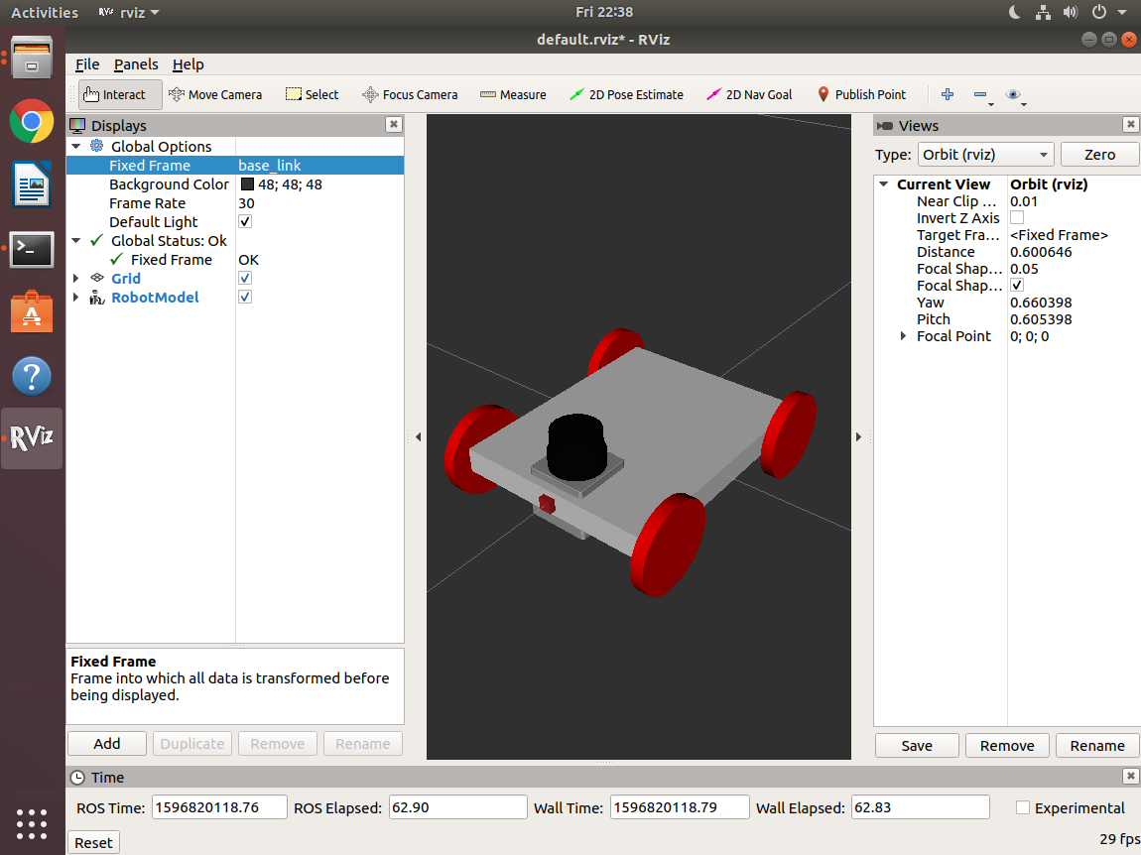

* To open gazebo simulator with robot in it, open terminal and type

roslaunch m4w_robot_gazebo mybot_world.launch



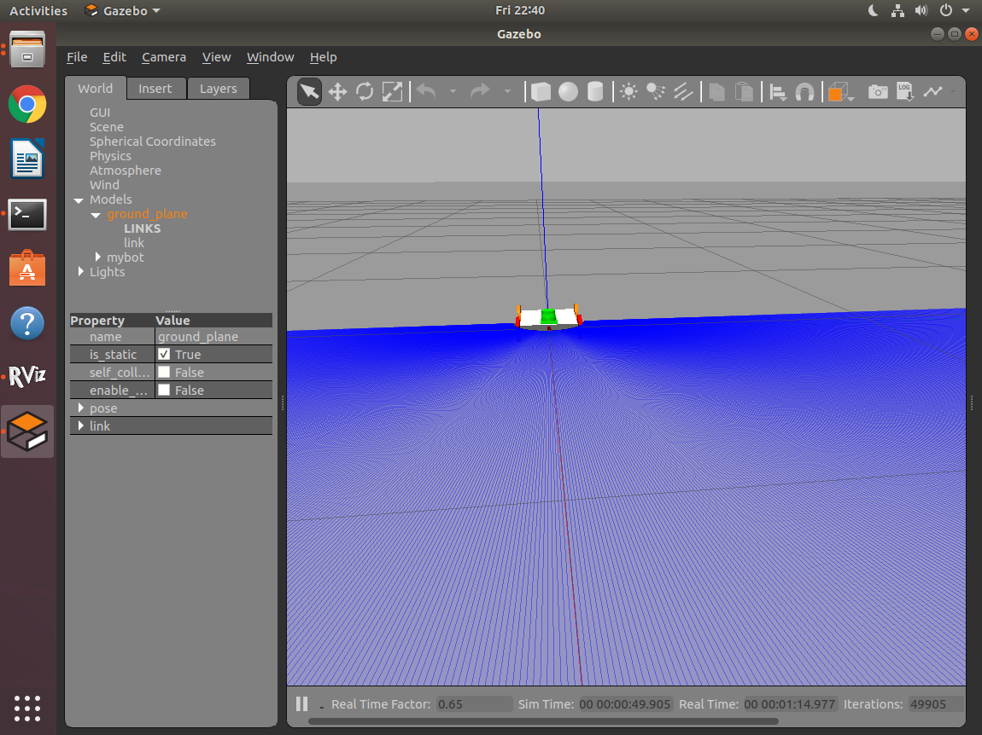

* After loading robot in gazebo simulator, we need to place some obstacles and objects in gazebo world to view them in RVIZ.

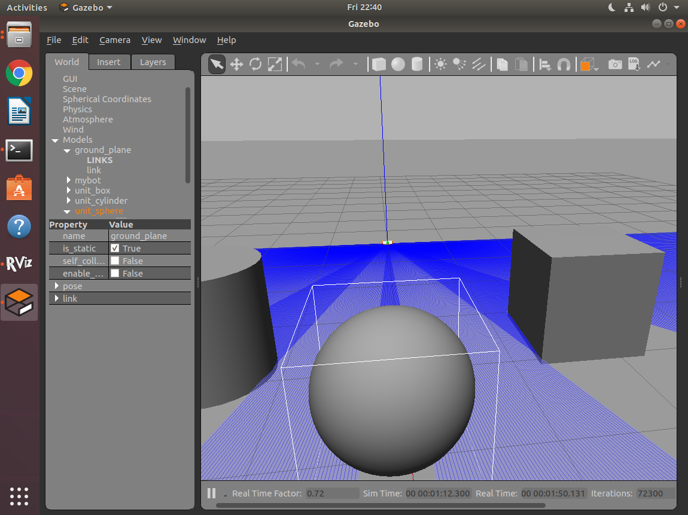

1. **Visualization obstacles as points in RVIZ**

* To open robot in RVIZ, open terminal and type

roslaunch m4w_robot rviz.launch

* To view camera output of robot in RVIZ.
* Open RVIZ and and add Laser scan from display type.

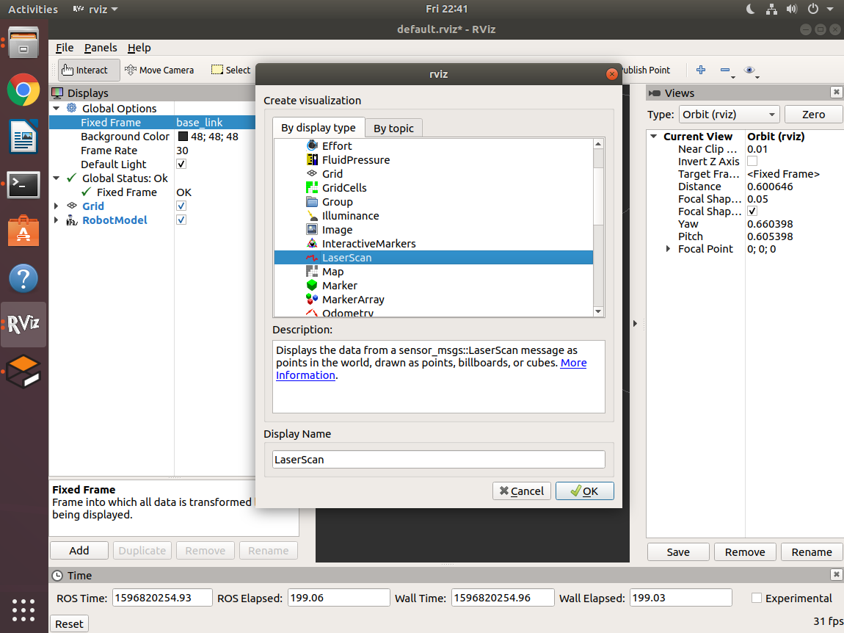

* In laser scan display type properties, in topic select the laser topic from drop down list, now obstacles in 3D world of gazebo simulator will be visible to us in red points in RVIZ display.



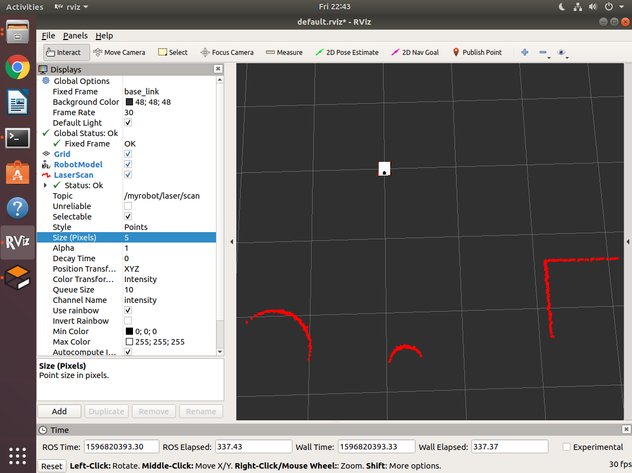

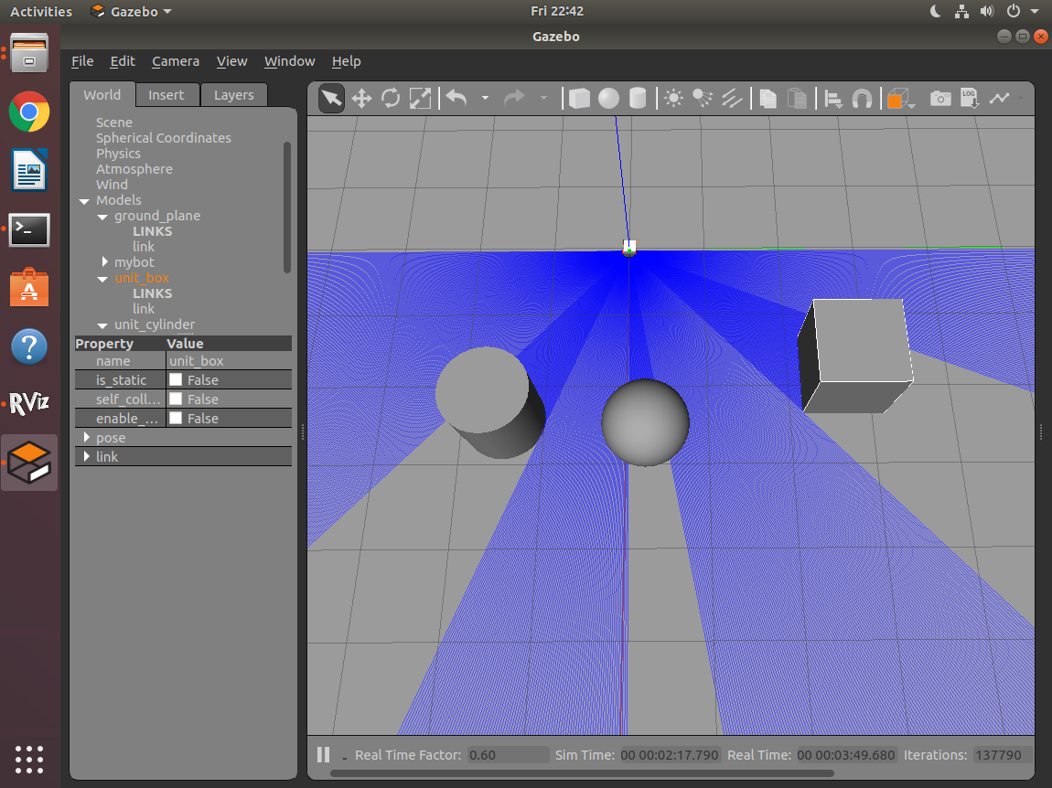

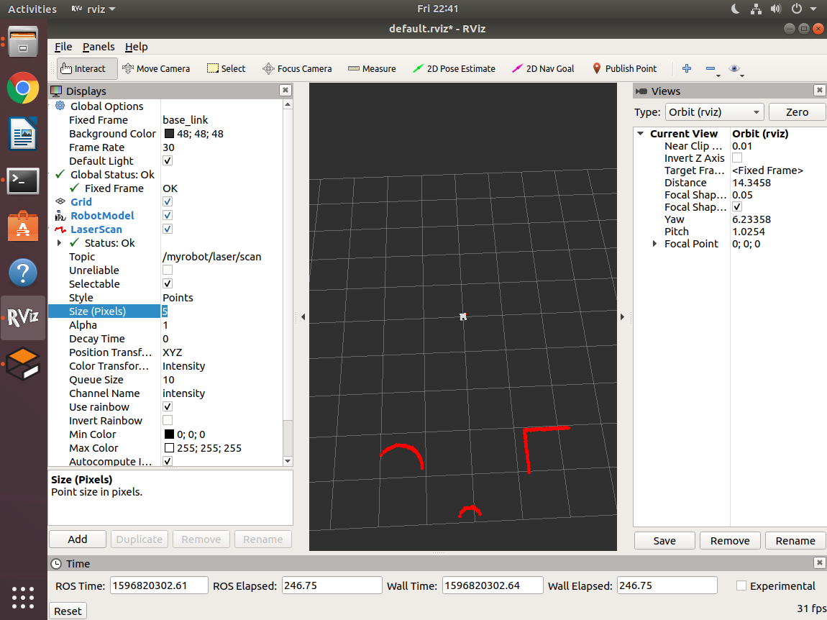

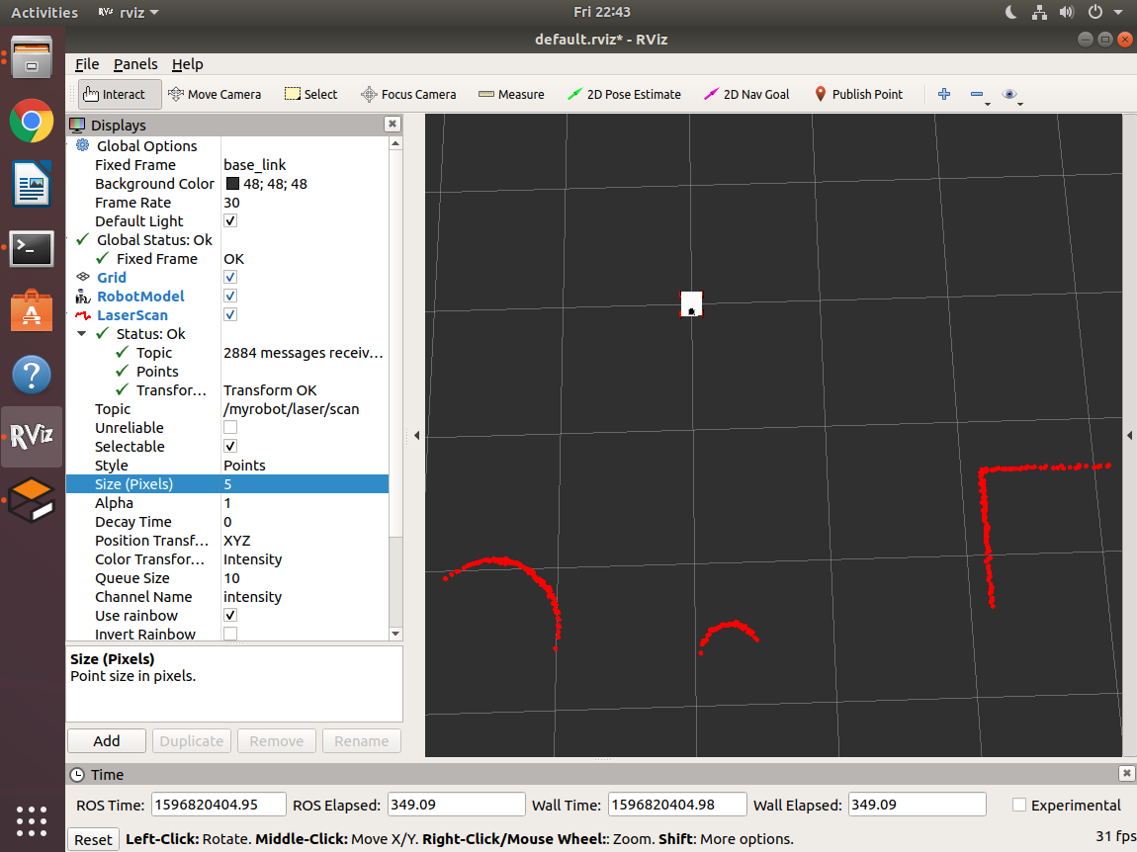

* Use teleop_twist_keyboard package to move robot in the world and see laser output in RVIZ display.

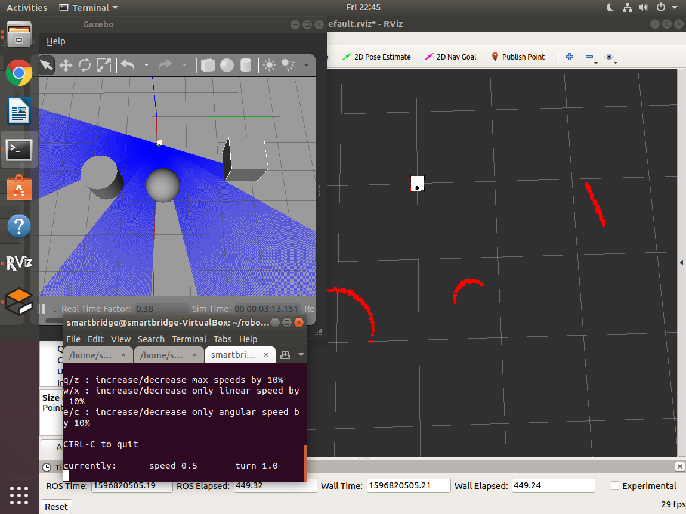

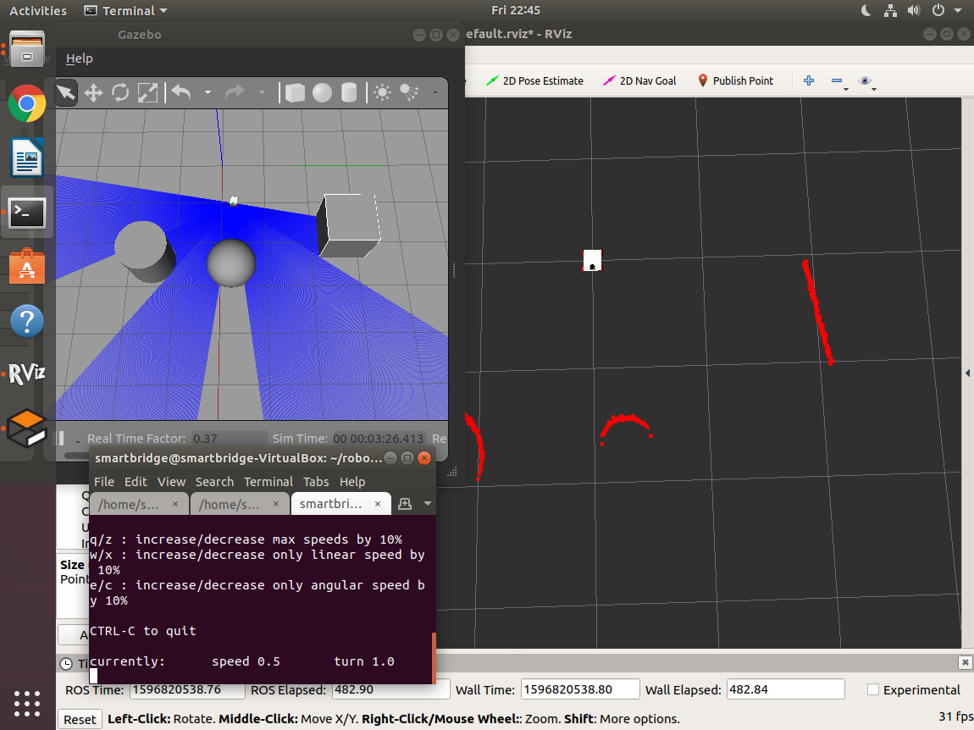

1. **Final robot**

* Finally, after camera and laser sensor is integrated open robot model and gazebo simulator and add camera, laser scan display types in RVIZ.
* Use **teleop_twist_keyboard** package to check camera and laser obstacles output in RVIZ.

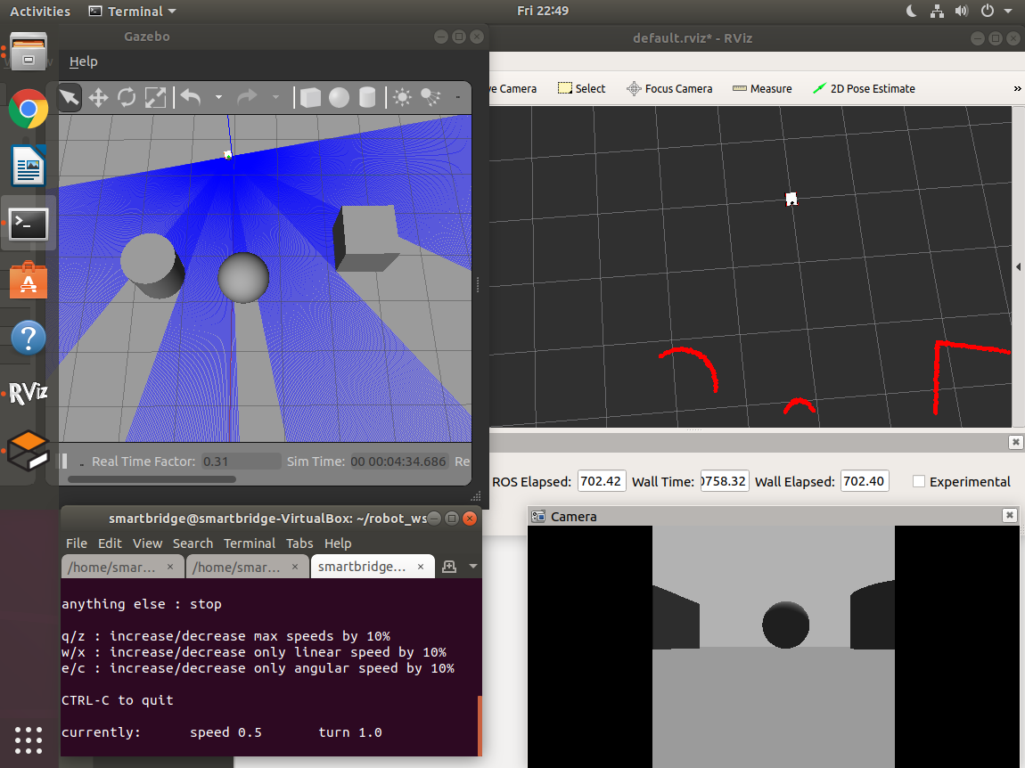

**GITHUB LINK FOR FOUR WHEEL ROBOT IN ROS**

<https://github.com/gnaneshwarb/four_wheeled_robot/tree/master/src/m4w_robot/meshes>